Sample Tracking
Velocity Field
Table of Contents
Velocity Field: A Custom Field Plugin 3
Behavior 3
Edit/Create 3
View 3
Search 3
Components 4
Issues 5
Life Cycle 5
Class Loading 6
Velocity calling Velocity 8
Velocity Environment 9
Configuration 11
Post function 12
Velocity templates 13
input-parameters 13
Edit Parameters 13
View 13
Fields 14
Database 14
Accessing other field values 15
Future Functionality 15
Note: 15
Ideas 17
Extending Velocity to make using decorators simple/possible 18
velocity.properties 18
PluginVelocityResourceLoader 18
Macro Libries 18
Directives 18
Version 18

Velocity Field: A Custom Field Plugin

Behavior

Edit/Create
An edit template can be defined in the fields configuration. It should have the full environment available to the edit.vm for a custom field. The same template is used during editing and creation and so will need to handle $value being null.

Future Functionality
The Velocity Field could be made a parent to other fields, that would only appear in edit. e.g. DB, Collection Code and BAC ID providing three separate fields for entering the values but being replaced by the velocity field when viewed.
Offer an option to not render the template if $value is null.

View
This is where the template would be used to render the value. The velocity environment would need to include the other fields and their values. (The actual fields could be configurable to reduce the time spent looking up all of the other fields values).
The other fields referenced will have to be static or higher on the page to ensure that their values have been set.

Future Functionality
Testing to ensure that there aren't circular references and that the other fields have already been rendered.
Determine cost of building the $fields variable. Options, to reduce the processing are:
Reduce the fields in $fields
Share $fields between multiple instances of VelocityCF that are on the same screen.

Search
The value to be searched, if any, could be different that the version in the view (e.g. no mark up) so a separate template should be available for searching. The template rendered template could either be entered into the index as a separate item per new line or multiple templates could be used.

Components
view.vm exec input String
xml.vm <customfield>
<value type A>XXXX</value type A>
<value type B>YYYY</value type B>
</customfield>
repeat for each value if there are multiple (A and B are components of a
'single' value)
searchers/label.vm Short name for hovering over graphs
Not Clear where this should be defined
FieldIndexer Parse velocity search template and then add a 'field' per line of the output

Issues

Life Cycle
The existing velocity templates are only used during page generation. This is fine for fields that are only views but causes problems with fields that will be searched on. The value seen is generated with the page. The value stored, and searched on, is set when the form is submitted. No templates are in use at this point.

Persistence Framework
There are 3 levels to the framework,
- The Database Level: Only simple types are supported (String, Number, Date), each Object is a single value (No arrays or lists)
- The Transport Level: The most flexible level this can be any type and most of the methods except arrays or lists of values.
- The Presentation Level: It all ends up a string in the HTML.
Input

Input

Diagram of CustomField Persistence interactions
'Get Value From Custom Field Params': This is the point where the contents of the HTML form is given to the Custom Field to convert into it's own Object type.
The input from the form could be transformed here but the values of the other fields aren't yet available via JIRA. They may be available from the form, but that misses out on any formatting and conversion the other fields do.
issue.isCreated can be used to tell if it is a new blank issue for the create issue page or an existing one for the edit page.

Class Loading
Using the separate instances of Velocity, via VelocityEngine, produces class loader problems. The ResourceManager is dynamically loaded and it appears that a separate class loader is used from the one that loaded the ResourceManager interface. This results in 'loadedResourceManager instanceof ResourceManager' always returning false. The exception thrown is of type org.apache.velocity.exception.MethodInvocationException. The exception contains the following message:

The specified class for ResourceManager (org.apache.velocity.runtime.resource.ResourceManagerImpl) does not implement org.apache.velocity.runtime.resource.ResourceManager; Velocity is not initialized correctly

The alternative, using the singleton version of Velocity(Velocity.class) also fails. It throws a java.lang.RuntimeException with a message of:

Velocity could not be initialized

This is also classloader related. The 'real' Velocity object must already be configured as the reverser was called from a velocity template. This seperately loaded class can be configured without changing the settings of the original Velocity object. Velocity objects can have their configuration and initialization methods called at any point without giving any error messages or throwing exceptions. Only the configuration calls before the first call to initialization actually change the settings. Once initialization has occurred all further calls are nop. Setting VelocityEngine.RUNTIME_LOG just changes the message to match the VelocityEngine attempt.

Using an implementation of ResourceManager outside of the Velocity jar still results in the same error message.

If the VelocityEngine is created outside of the Velocity template being processed...

This can be done by constructing a single static? VelocityEngine to share. The construction doesn't need any specific information about a particular issue or use and so can take place in the constructor. The constructor shouldn't throw an Exception and so any problems found must be stored in the same way as the VelocityEngine. When the velocityEngine would be used to parse a template the error message is returned instated.
Creating the VelocityEngine in the constructor oddly failed in the same way.
Creating the VelocityEngine in the static constructor failed in the same way.
Previous tests inside getVelocityParams worked so try there... failed
Can't pass static references...
would using a static method called from the class work?
Static call works from Singular object to String

Solution; for Class Loading
JIRA's plug-ins is use dependency injection controlled by the PicoContainer. PicoContainer acts as a central object factory. It is responsible for instantiating objects and resolving their constructor dependencies. Plug-ins can include in their constructors various 'Manager' interfaces and when the class is instantiated the PicoContainer will find implementations of those interfaces to pass into the object.

Velocity calling Velocity
#if ($displayParameters.defaultScreen)
#controlHeader ($action $customField.id $customField.name $fieldLayoutItem.required $displayParameters.noHeader)

<textarea name="$customField.id"
id="$customField.id"
class="textfield"
rows="4" cols="40" wrap="virtual"
>$textutils.htmlEncode($!value)</textarea>

#controlFooter ($action $fieldLayoutItem.fieldDescription $displayParameters.noHeader)
#else
#if ($defaultValue)
$VelocityManager.getEncodedBodyForContent($defaultValue,
$baseurl,
$ctx)
#end
#end

Velocity Environment
Object | Description
action  Not Needed for view | unknown  Calling action.
applicationProperties See Description | com.atlassian.jira.config.properties.ApplicationProperties Via constructor or ComponentManager
authcontext  Via constructor | com.atlassian.jira.security.JiraAuthenticationContext  for authentication information
baseurl | String  The getContextPath of the req object  NOT AVAILABLE
buildutils  Empty constructor | com.atlassian.jira.util.BuildUtils  has information on build numbers, editions etc. (deprecated)
config  Not Needed for view | com.atlassian.jira.issue.customfields.config.CustomFieldConfig
configs  Not Needed for view | unknown  The various configuration items for that context.
constantsManager  See Description | com.atlassian.jira.config.ConstantsManager  Object for managing "constants" (issue types, resolutions...) Via constructor or ComponentManager
customField  From parameter | com.atlassian.jira.issue.fields.CustomField  Information on the current field.
customFieldParams See Description | com.atlassian.jira.issue.customfields.view .CustomFieldParams  This is where the value is pulled from, for convenience (CustomFieldParams) customField.getValue(issue)
dateutils  Empty constructor | com.atlassian.core.util.DateUtils  utilities for dates
descriptor | CustomFieldTypeModuleDescriptor  The module descriptor of the current field  CustomFieldType.getDescriptor()
displayParameters  Not Needed for view | unknown  Custom parameters to the template, such as whether to display headers
fieldLayoutItem  Not Needed for view | com.atlassian.jira.issue.fields.layout.field.FieldLayoutItem isRequired, isHidden etc
i18n  See Description | com.atlassian.jira.web.bean.I18nBean  utilities for internationalization JiraAuthenticationContext.getI18nHelper()
issue  From parameter | com.atlassian.jira.issue.Issue  Access to the issues properties
jirakeyutils  Empty constructor | com.atlassian.jira.util.JiraKeyUtils  utilities for parsing keys
jirautils  Empty constructor | com.atlassian.jira.util.JiraUtils  general utilities
outlookdate  See Description | com.atlassian.jira.web.util.OutlookDate  for formatting dates, JIRA style  JiraAuthenticationContext.getOutlookDate()
projectManager  See Description | com.atlassian.jira.project.ProjectManager  Via constructor or ComponentManager.getInstance().getProjectManager();
req | HttpServletRequest  NOT AVAILABLE
textutils  Empty constructor | com.opensymphony.util.TextUtils  utilities for text manipulation needs
userutils  Empty constructor | com.atlassian.core.user.UserUtils  utilities for getting users
value  From persistence framework | String  value of the custom field. Other types are used by other fields
velocityhelper  Empty constructor | com.atlassian.jira.util.JiraVelocityHelper  general utilities (deprecated)

All but 'baseurl', 'descriptor' and 'req' can be provided to the instance creating the value to store!
The Interface VelocityManager provides a wrapper similar to Velocity's static Velocity class.

public void addDocumentFieldsSearchable(Document doc, Issue issue)
public void addDocumentFieldsNotSearchable(Document doc, Issue issue)
The addDocumentfields methods are still called on create even if the value of the field wasn't set

------------------
Calls Velocity Params followed by getObjectFromDbValue when viewing an issue.

Configuration
The configuration is done through a custom action, which extends AbstactEditConfigurationAction.

URL parameters | AbstractEditConfigurationAction methods | JiraWebActionSupport methods
fieldConfigSchemeId
customFieldId | getCustomField
fieldConfigId | setFieldConfig  getfieldConfig
returnUrl |  | setReturnUrl  getReturnUrl
setSelectedProjectId
getSelectedProjectObject
getSelectedProjectId

Post function
Configuration
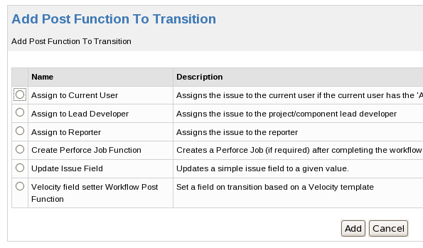
The name and description come from the atlassian-plugin.xml file.
<workflow-function name="Velocity field setter Workflow Post Function" ...>
<description>
Set a field on transition based on a Velocity template
</description>

Velocity templates

input-parameters
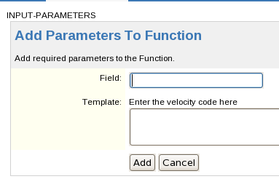
The template is inserted within the existing form and between table rows. The box around with the grey heading area is produced by JIRA. Adding content outside of <tr><td> tags results in it appearing before the table. The names of the inputs must match the names getDescriptorParams uses to get the data.

Edit Parameters
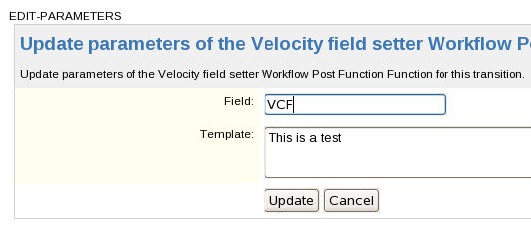
This is the same as the CREATE-PARAMETERS template except that the values are available as variables. The variables are names the same as the keys in the map returned by getVelocityParameters For...

View

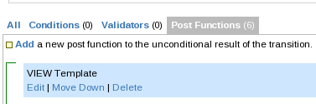
No form or table this time but the variables are still present.

Fields

Database
The Database field is set from the first part of the Summary / Sample ID fields. The format for these fields is:
<Database>_<Collection Code>_<BAC ID>
Splitting on '_' should give a 3 entry string array, with:
- 0 Database
- 1 Collection Code
- 2 BAC ID
Although a test will be needed to check, in case an invalid format has been used.

Note: RegEx
Velocity allows direct access to an objects methods. This includes String which includes several string handling methods and some RegEx methods. In particular for separating the components in the summary field there is the method split which divides the string it is called on where-ever the passed in separator occurs (the separator can be a regEx).

Edit/Create
A static message of 'This field is automatically set when the issue is saved'

view
The value stored for the field should be the same as the value we would display and so this
only needs to contain
$!value

Search/Store
This is where the processing is done, Sample ID should have been set by now and can be accessed via $fields.get('Sample ID') or $fields.get('10099') where 10099 is the custom field's ID.
#if ($fields['10099'])
#set $parts = $fields.get('10099')
#set $value = $parts[0]
#end if
$!value

Accessing other field values

Should be in implementation section

Sample code for accessing a CustomField's value in JIRA

An Issue object is needed to identify the record who's field will be read.
Issue must not be NULL
The issue has to have been created or none of the fields will have values , tested by:
issue.isCreated()

Use CustomFieldManager to get the CustomField wanted .
A non-NULL CustomFieldManager is returned from:
ManagerFactory.getCustomFieldManager()

The CustomField can be accessed by visible name or id number:
fieldManager.getCustomFieldObjectByName("BAC Id");
fieldManager.getCustomFieldObject((long)10010);
The CustomField could be NULL

The value can be accessed through the Issue object. Some of the CustomField implementations include methods to get the value, but these don't seem to work reliably with external fields.
issue.getCustomFieldValue(otherField);
The Object returned could be NULL

The methods return type is object, the actual type of the returned object depends on the field's type. BAC Id returns an instance of Number

Future Functionality
- More options for using searchers, including possibly multiple searchers on one field.
Initially the field will be marked as supporting all searchers (date, number, string) and then the actual one required can be set in the administrator section of JIRA.
- Template shaing
- Access to of the standard JIRA templates
- AJAX tester
- A method of setting up a mock environment
- Having local and global configurations (global available in all views)
- Extensions via adding to the environment
- DB object (although this may require excessive code in velocity to actually use)

Note:
Indexer gets called independently of if the field is displayed or has a value.

Ideas
- Provide custom fields as parameters to the velocity custom field to save having separate hidden fields (that get the data) and then velocity fields that display it.
- The configuration will need to be able to accept configuration for the sub-fields

- ImportUtils.setIndexIssues(true);
indexManager.reIndex(newIssue);
ImportUtils.setIndexIssues(false);
The indexing of issues during workflow transitions is turned off by
default

Extending Velocity to make using decorators simple/possible
The Velocity Engine gets its parameters from velocity.properties, loaded as a Properties object. The initializer can take a replacement Properties object.
public void VelocityEngine.init(Properties)
The VelocityEngine instance used by JIRA is constructed in an inaccessible class.

velocity.properties
contains:
plugin.resource.loader.class=com.atlassian.jira.plugin.PluginVelocityResourceLoader

PluginVelocityResourceLoader
Seems to be for getting the templates, not for adding functionality.

Macro Libries
- template/email/macros.vm
- template/plugins/jira/macros.vm
- template/jira/issue/table/macros.vm
- template/jira/global.vm
The global one seems to get included everywhere.
If we had Velocity 1.7 then we could add a block macro that acted much like the tags do in the JSP

Directives
In Velocity 1.6 a method was added to allow extending velocity with 'directives' which are written #xxx, the same as the built-in #if etc.
RuntimeInstance.addDirective()

Version
Searching the directories for files with velocity and jar in their name; the only files that were actually for velocity were:
- velocity-1.4-atlassian-1.jar
- velocity-tools-1.3.jar
Which is too only for Directives or Block Macros.
Updating the POM file to include velocity 1.7 as a run-time requirement broke much of JIRA.

It's not clear where this value comes from, it may not be related to the value in the URL

